Spanning Tree

A spanning tree is a subset of Graph G, which has all the vertices covered with minimum possible number of edges. Hence, a spanning tree does not have cycles and it cannot be disconnected..

By this definition, we can draw a conclusion that every connected and undirected Graph G has at least one spanning tree. A disconnected graph does not have any spanning tree, as it cannot be spanned to all its vertices.

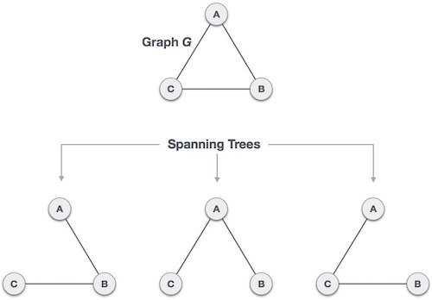

## Minimum Spanning Tree (MST)

In a weighted graph, a minimum spanning tree is a spanning tree that has minimum weight than all other spanning trees of the same graph. In real-world situations, this weight can be measured as distance, congestion, traffic load or any arbitrary value denoted to the edges.

Differentiate between Prim’s and Kruskal’s algorithm.

